CHEMISTRY 12 ATCHE Task 9

2023 Organic Chemistry TEST ANSWER SHEET

Recommended time: 45 minutes
Total marks

/ 46
Name: SOLUTIONS

Teacher: _____________________________________________________

This test has three sections.

Section 1: Multiple choice style consisting of six (6) questions.
Each question is worth 2 marks.
Write your answers in the multiple choice answer sheet provided.

Section 2: Short answer questions consisting of four (4) questions worth 18 marks.
The marks allocated to each question are shown next to each question.
Write all answers in the spaces provided.

Section 3: One (1) extended response question worth 15 marks.
The marks allocated to each part are shown next to each part.
Write all answers in the spaces provided.


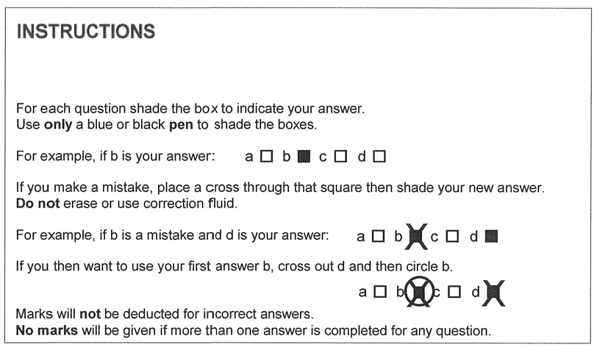

1. | a o | b o | c o | d o
2. | a o | b o | c o | d o
3. | a o | b o | c o | d o
4. | a o | b o | c o | d o
5. | a o | b o | c o | d o
6. | a o | b o | c o | d o

/6

SECTION ONE: MULTIPLE CHOICE QUESTIONS (12 marks)
- Consider the molecule aspartame, shown below.
Which of the following functional groups is not present in aspartame?
- amine
- alcohol
- amide
- ester

- Which of the following molecules could have a geometric isomer?
- 1,1-chloro-prop-1-ene
- 1,2-dichloroprop-1-ene
- but-1-ene
- 2-chlorobut-1-ene

- The following shows the reaction between dodecyl sulphate and sodium hydroxide:
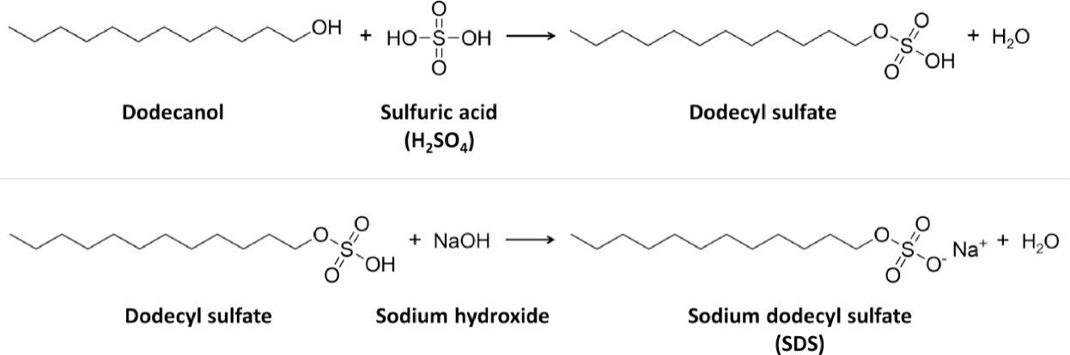
Which of the following options best describes the reaction taking place as well as the class of the ionic product?

Reaction Type Chemical Class
- Saponification Detergent
- Saponification Soap
- Neutralisation Detergent
- Neutralisation Soap

- The following graph shows the boiling point of four different hydrocarbons – propanone, propan-1-ol, propanoic acid, and propanal.

Which compound is most likely to be propanoic acid?

- A
- B
- C
- D

- Which of the following substances would you expect to have the highest boiling point?
- ethanoic acid
- methanoic acid
- ethanal
- ethanol

- Consider a micelle formed from soap particles, as shown below. The two (2) distinct regions of the soap particle are labelled as X and Y.
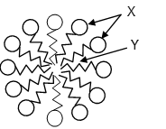
Which of the following correctly identifies X and Y?
X Y
- Polar head Non-polar tail
- Non-polar head Polar tail
- Polar tail Non-polar head
- Non-polar tail Polar head

END OF SECTION ONE
SECTION TWO: SHORT ANSWER QUESTIONS (19 marks)

Question 7 (3 marks)
Complete the following table showing the structure and names of three organic compounds.

Structure | IUPAC Name
 | 3-methylpentan-2-one
 | 5-methylhexan-3-amine
 | 2-methylpentan-3-one

Question 8 (6 marks)
Complete the table by drawing the structure and giving the IUPAC name of the organic compounds that match each of the following descriptions.

Description | Structure | IUPAC name
A saturated tertiary alcohol containing 12 hydrogen atoms |  | 2-methylbutan-2-ol
An ester that is an isomer of hexanoic acid and made from ethanol |  | ethyl butanoate
A hydrocarbon that could be used to make 1,2-difluoro-3-methylbutane via an addition reaction |  | 3-methylbut-1-ene

Question 9 (6 marks)
The following synthetic pathway shows the formation of ethyl ethanoate from ethene.

Write out the reactions in equation form, making sure to show any reactants or products not mentioned in this synthesis diagram. (you may use molecular, full or condensed formula at your preference)

A C₂H₄ + H₂O à C₂H₅OH
H₃PO₄
2 marks, only 1 if catalyst is missed or if trivial mistake in formula (1 mark off per mistake). States not required

B 3CH₃CH₂OH + 2Cr₂O₇²⁻ + 16H⁺ à 3CH₃COOH + 4Cr³⁺ + 11H₂O

2 marks, 1 mark for correct species, 1 mark for correct balancing

C CH₃CH₂OH + CH₃COOH à CH₃CH₂OOCH₂CH₃ + H₂O
H⁺ CH₃COOCH₂CH₃

2 marks, 1 mark for equation one mark for catalyst.

Space for working:

Question 10 (4 marks)

Describe, with the use of an appropriate equation, how the salt of a 16 carbon long saturated fatty acid salt can be prepared from a triacylglyceride (triglyceride).

The reaction between a triglyceride and a base is called saponification
During this reaction the ester bond in the molecule is broken
This produces a glycerol molecule and three fatty acid salts
(C₁₆H₃₁O)₃C₃H₅O₃ + 3NaOH à 3 C₁₆H₃₁O₂Na + C₃H₈O₃
C₁₅H₃₁COONa

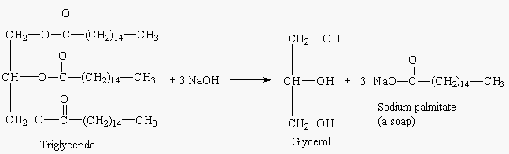

END OF SECTION TWO

SECTION THREE: EXTENDED RESPONSE QUESTIONS (15 marks)
Question 11 (15 marks)
Kevlar, a remarkable polymer, can be fashioned into various forms such as fibres, sheets, and rods. Kevlar's broad-ranging applications stem from its exceptional mechanical strength, light weight, high heat resistance, and remarkable chemical stability. It is most renowned for its use in bulletproof vests, owing to its extraordinary ability to absorb and distribute energy.
A segment of kevlar is shown in the diagram below.
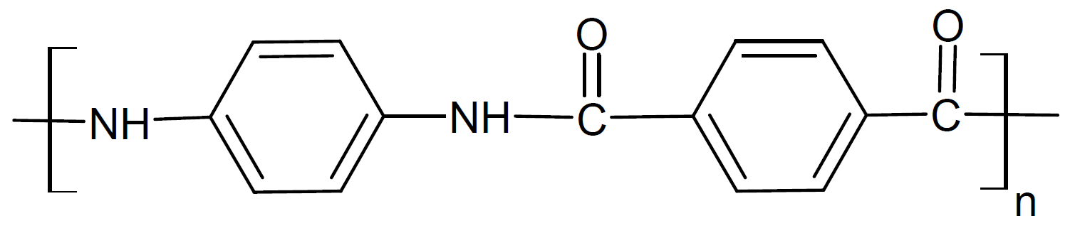
(a) Explain why Kevlar has such high tensile strength in terms of its intermolecular forces.
(2 marks)
- Kevlar is able to exhibits hydrogen bonding, dipole-dipole bonding, and dispersion forces between lengths of the polymer OR the predominant intermolecular force in kevlar is hydrogen bonding
- As the sum of these intermolecular forces are high, the energy required to break them is high, leading to a high tensile strength
(b) Draw the two (2) monomers from which kevlar is composed. (2 marks)
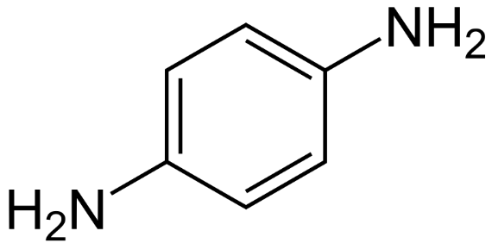 | 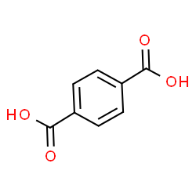
(c) Name and briefly describe the process by which these monomers are able to form this kevlar polymer. (2 marks)
- condensation polymerisation
- a water molecule is eliminated (OH from each carboxylic acid group and H from each amine group) as the monomers link together to form nylon
A pure sample of an amine (containing only the elements carbon, hydrogen and nitrogen) was analysed to determine its composition. The amine was combusted in oxygen and produced 6.60 g of carbon dioxide, 1.80 g of water and 0.70 g of nitrogen gas.
(d) Calculate the empirical formula of the amine. (7 marks)

 | C | H | N
m | = 12.01 / 44.01 x 6.60  = 1.801 g | = 2.016 / 18.016 x 1.80  = 0.2014 g | = 0.7g
n | = 1.801 / 12.01  = 0.149958 mol | = 0.2014 / 1.008  = 0.1998 mol | = 0.7 / 14.01  = 0.04996 mol
ratio | 3 | 4 | 1

Therefore EF is C₃H₄N

(e) Does this analysis provide any evidence that supports this amine might be the one used to make kevlar? Explain. (2 marks)
- yes the information proves this amine is one of the monomers in the Kevlar polymer
- the MF of the polymer amine is C₆H₈N₂

END OF TEST

